# Assignment 7 - Univariate Analysis (23.5 points)

## Instructions

1. Answer the below question in the boxes if needed.
2. For coding exercises, code in a single google colab notebook and zip all your code before submission.
3. Please submit the assignment through TalentLabs Learning System

**Question 1 (3.5 points)**

Interpret and write your insights for the following plots, you are given data description for your reference and the goal.

Our data for this question, adult overweight/obesity rates by state, come from the [Kaiser Family Foundation](http://kff.org/other/state-indicator/adult-overweightobesity-rate/). The data file, a comma-separated values file called adult_data.csv is provided to you.

Data contains the name of the state; then all_adults, male, and female, which contain the overweight/obesity rates for that state overall and by gender. Snippet below.

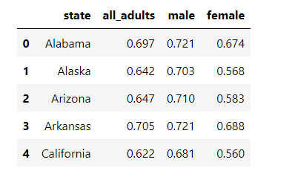

Now given this data, answer the following:

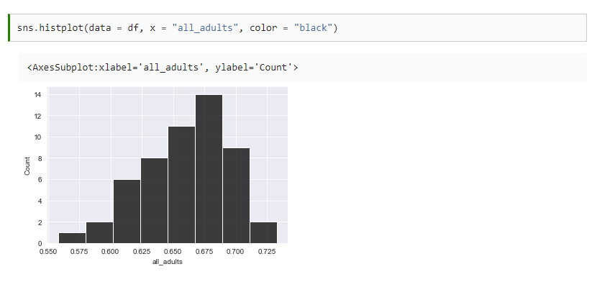

1. What kind of variable is “all_adults”?  
   (Numerical: discrete or continuous, Categorical: ordinal or nominal) (1 point)

|  |
| --- |
| Numerical: continuous |

1. What kind of plot/chart is this? (0.5 point)

|  |
| --- |
| Histogram chart |

1. What does the plot show? (1 point)

|  |
| --- |
| It shows the frequency distribution of adult overweight/obesity rates by state, come from the Kaiser Family Foundation. |

1. How many states are having obesity rates between 0.625 and 0.675 throughout the US according to the dataset roughly(see the plot)? (1 point)

|  |
| --- |
| 8 states |

**Question 2 (2 point)**

Read the description below and answer the following questions:

Mr Khosa asked each learner in his class to name their favorite sport and he plotted it out below.

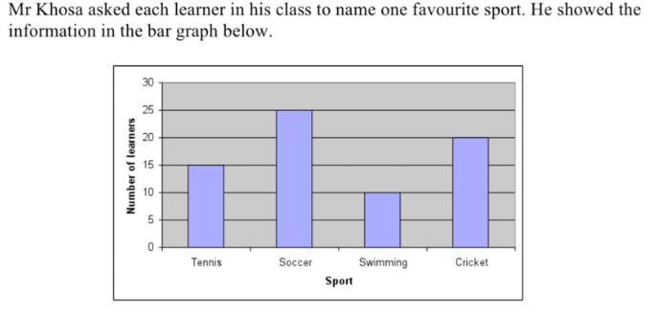

1. What kind of a plot/chart is this? What is the data type of variable being analyzed here (categorical or numerical)? (0.5 point)

|  |  |  |  |  |  |  |
| --- | --- | --- | --- | --- | --- | --- |
| Bar plot  There are 2 variables analyzed as below:   |  |  | | --- | --- | | Variable | Data type | | Sport | String - categorical | | Number of learners | Numerical - continuous | |

1. How many learners are there in Mr Khosa’s class? (0.5 point)

|  |
| --- |
| Assuming each learner has only 1 class, there are 70 learners in total. |

1. Which is the most popular sport and the least popular sport here? How many learners are in each?(1 point)

|  |
| --- |
| Most popular - Soccer  Least popular - Swimming |

**Question 3 (2 points)**

Distribution of water usage from different water sources. Study and answer questions below(2 point):

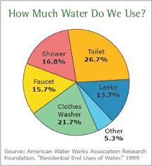

1. What kind of plot/chart is this? What is the data type of variable being analyzed here (categorical or numerical)? (0.5 point)

|  |
| --- |
| Categorical |

1. Which source of water utilizes the most water vs least water? What is the percentage of water used in each? (1 point)

|  |
| --- |
| The most - Clothes Washer (21.7%)  The least – Leaks (13.7%), if exclude Others (5.3%) |

1. Why are pie charts not used that often? What are the alternatives(0.5 point)

|  |
| --- |
| It is messy to compare too much categorical variables (e.g., >10) inside pie chart.  Bar chart could be the alternative when the data has too much categorical variables to compare with. |

**Question 4 (2 points)**

1. Which of these is one reason to run a univariate analysis?
   1. To understand relationships between variables
   2. To understand and compare groups.
   3. To understand a variable and glean insights
   4. To predict one variable based on another
2. Univariate data cannot answer research questions about relationships between variables, but rather, it is used to describe:
   1. All related variables to the outcome
   2. The characteristics that vary randomly
   3. One characteristic or attribute that varies from observation to observation
   4. Relationships among variables

**Question 5 (4 points)**

With the plot given below, answer the following questions: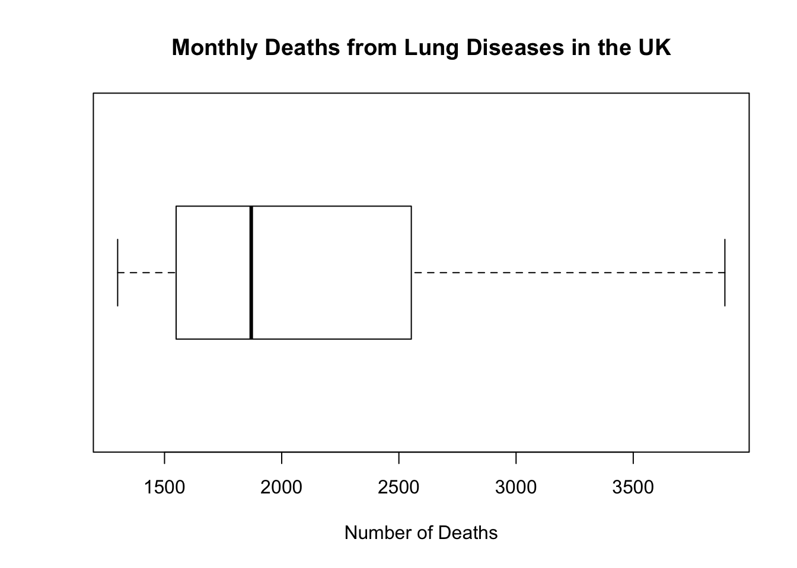

* What type of plot do we see? (0.5 point)

|  |
| --- |
| Box plot |

* What are the five summary statistics values here roughly? (2.5 point)

|  |
| --- |
| Median  Q1  Q3  Lower boundary (Q1 – 1.5 * IQR)  Upper boundary (Q3 + 1.5 * IQR) |

* Give the Interquartile Range and does the plot above have outliers?(1 point)

|  |
| --- |
| Interquartile Range = Q3 – Q1  = 2,600 – 1,600  = 1,000  The plot above doesn’t have outliers, as no data points beyond upper and lower boundary of box plot. |

**Question 6 (10 points)**

Load the titanic dataset using seaborn using and answer the questions below

import seaborn as sns

df = sns.load_dataset(‘titanic’);

Study the dataset and the goal here: <https://www.kaggle.com/competitions/titanic>

You can use seaborn or matplotlib or plotly or all of them.

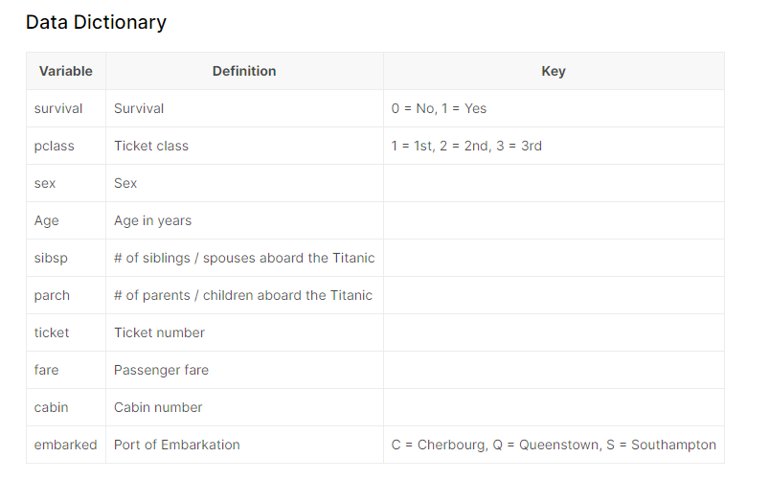

* How many people survived the titanic? Plot a graph. (2 points)

|  |
| --- |
| Screenshot of the chart:    Number of people who survived: 323 |

* What was the ratio of Males to Females on the titanic? Plot a graph (2 points)

|  |
| --- |
| Screenshot of the chart:    Male - Female Ratio:  Male: 62.6%  Female: 37.4% |

* Make a pie chart of the number of people from different ticket classes. Make sure you **deduplicate the data as a whole and remove any null values in the class variable and generate the chart.** Use the ‘class’ variable. (1 point)

|  |
| --- |
| Screenshot of the chart: |

* What is the distribution of the Fare paid by people? Plot a histogram and tell us what you see? How many people paid between 0 and 100 dollars, while how many paid more than 300 dollars? Also make a boxplot? Make sure they align in terms of the x axis. Give us the interquartile range by using quantile function in pandas. (5 points)

*Hint: Use plt.subplots with sharex=True and figsize=(20,10)*

|  |
| --- |
| Screenshot of the charts:    Insight: The distribution of fare is right skew, and a lot of outliers beyond its upper boundary.  People who paid Fare between 0 and 100: 721  People who paid Fare above 300: 3  IQR: 26.05935 |